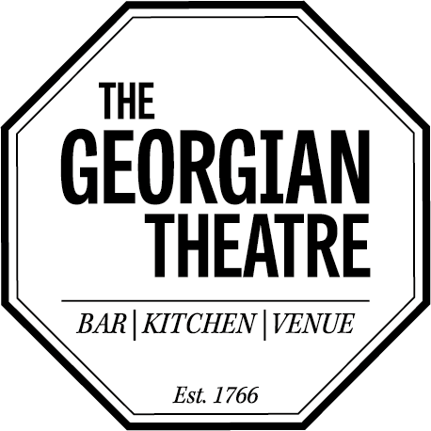
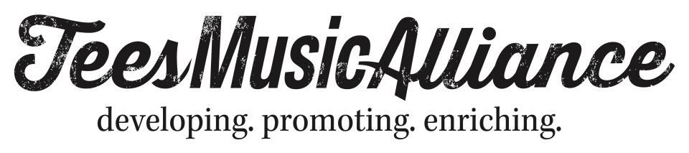

TMA – ACCESS INFORMATION

TMA is keen to promote equality of opportunity for people with disabilities and to take the necessary steps to meet their requirements.

Our venue is wheelchair accessible with ground floor access to our performance spaces, our bars and our adapted toilets. We have a part of our main (ground floor) bar that is lowered for wheelchair users; in addition, a member of staff will always be happy to help you if needed.

We recognise that people with accessibility requirements may need to have someone with them. For this, we offer a free ticket to personal assistants / carers. You can make this arrangement through the venue by contacting us on 01642 606525.

If you consider yourself to be disabled but you don't use a wheelchair and find it uncomfortable at standing events; please contact us after you book your tickets and we can arrange to provide you with a seat. This will usually be a folding chair that you can use as little or as often as required throughout the event for your comfort.

Nearly all of our music events are non-seated.

However, at events where seating at tables is offered as standard - usually smaller, cabaret style shows; comedy etc. - please contact the venue to reserve a seat or a table

If you need any assistance during your visit, please don't hesitate to ask a member of staff.

If you need any advice or information before your visit - or would like to leave feedback or a suggestion afterwards; we can be contacted at access@teesmusicalliance.org.uk

